**ANALYSIS OF CRIMES IN CITY OF CHICAGO**

**NAME: ADITYA PATIL**

**CIN: 304746057**

Fall 2016

CIS 5270 – 01 Business Intelligence

Prof. Shilpa Balan

**TABLE OF CONTENTS**

|  |  |  |
| --- | --- | --- |
| **SR. NO** | **TITLE** | **PAGE NO.** |
| 1 | Data Sets | 3 |
| 2 | Data Cleaning | 4 |
| 3 | Data Visualizations | 9 |
| 4 | Dashboard | 14 |
| 5 | Story Telling | 15 |
| 6 | References | 22 |

**A. DATA SETS**

The dataset is picked up from

<https://data.cityofchicago.org/Public-Safety/Crimes-2001-to-present/ijzp-q8t2>. The project is built up with the help of these datasets. These datasets reflects the crime occurred in the city of Chicago. Data is extracted from the Chicago Police Department’s CLEAR (Citizen Law Enforcement Analysis and Reporting) system.

Data set URLs:

1. <https://data.cityofchicago.org/Public-Safety/Crimes-2001-to-present/ijzp-q8t2>
2. <https://data.cityofchicago.org/Public-Safety/Crimes-2013/a95h-gwzm>
3. <https://data.cityofchicago.org/Public-Safety/Crimes-2014/qnmj-8ku6>
4. <https://data.cityofchicago.org/Public-Safety/Crimes-2015/vwwp-7yr9>

Explanation of the data sets URLs:

This dataset reflects reported occurrences of wrongdoing that happened in the City of Chicago. These crimes might be based upon preparatory data provided to the Police Department by the reporting parties that have not been confirmed. The preparatory crimes arrangements might be changed at a later date based upon extra examination and there is dependably the likelihood of mechanical or human mistake. This dataset contains huge amount of data for several years.

These datasets offer the information about the Number of Crimes Reported, Description of the crimes, Location details related to crimes occurred as well as the year for which the crime has occurred. These dataset contains data from the years 2013, 2014 and 2015 respectively. Each data sets have over 250000 rows.

**B. DATA CLEANING**

More often than not the information includes pointless data. That should be erased or adjusted and the information sets should be refined to make sense. The accompanying pictures will clarify what was the unrequired data in the information sets and how it was cleaned.

**1. Missing values**

In the ‘Location Description’ column there are missing values which can be eliminated to clear the data.

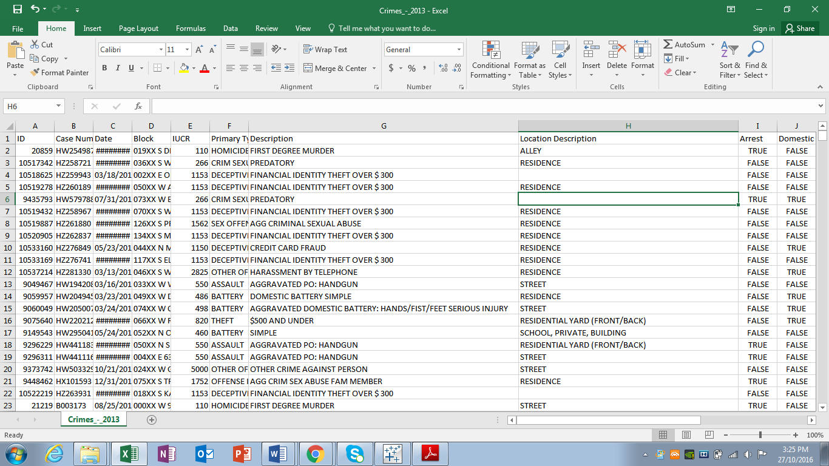

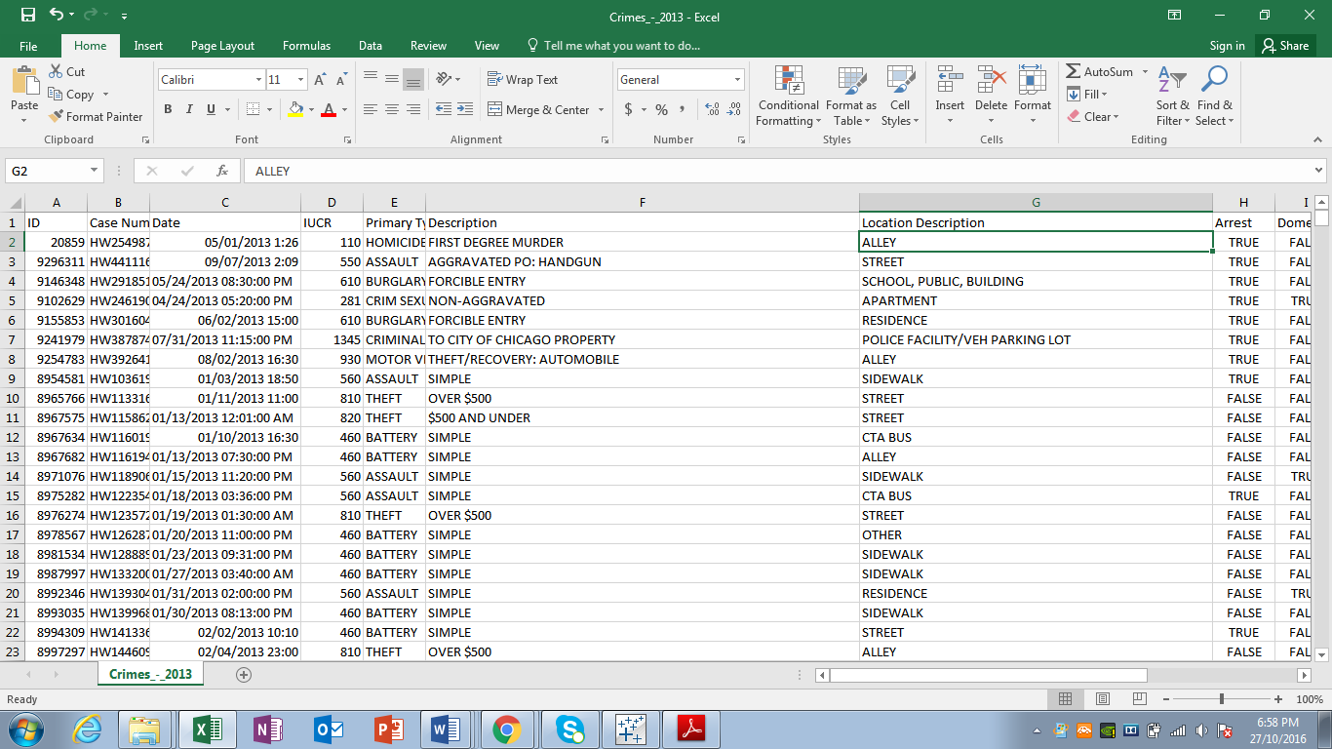

**2. Unrequired columns**

Some Columns in the dataset are unnecessary and can’t be used while analyzing the data. The column named ‘Block’ has the location that are kept incomplete to secure the privacy of the victims. Hence, that block can be deleted from the table. Here are the before and after shot of the data set

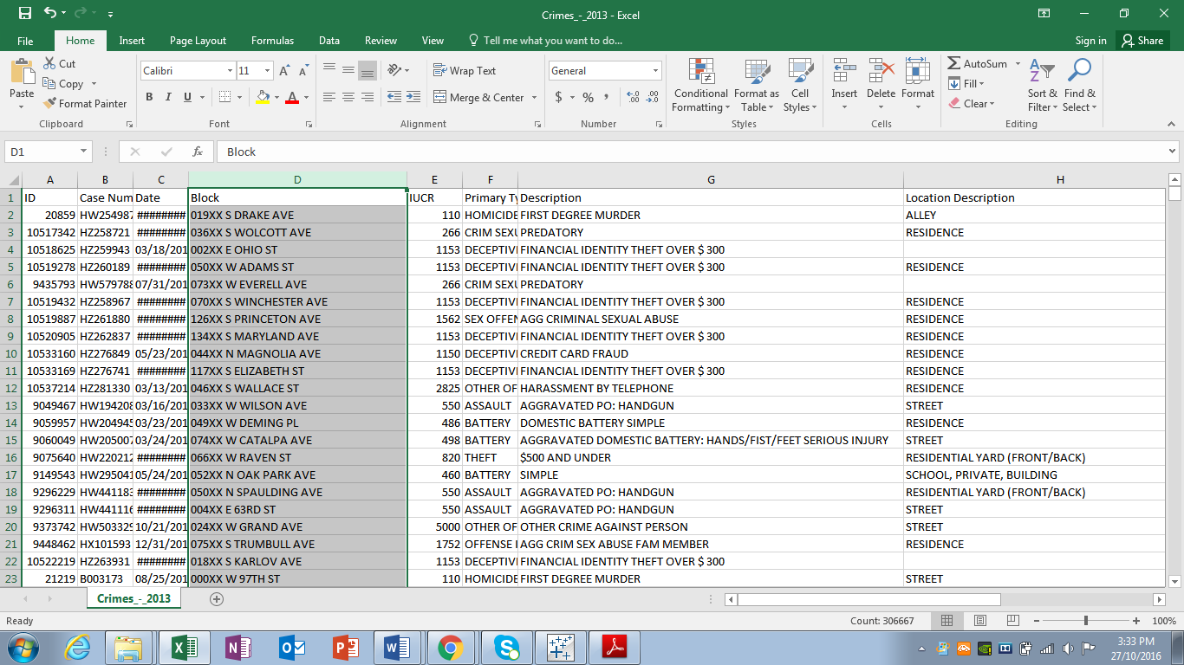

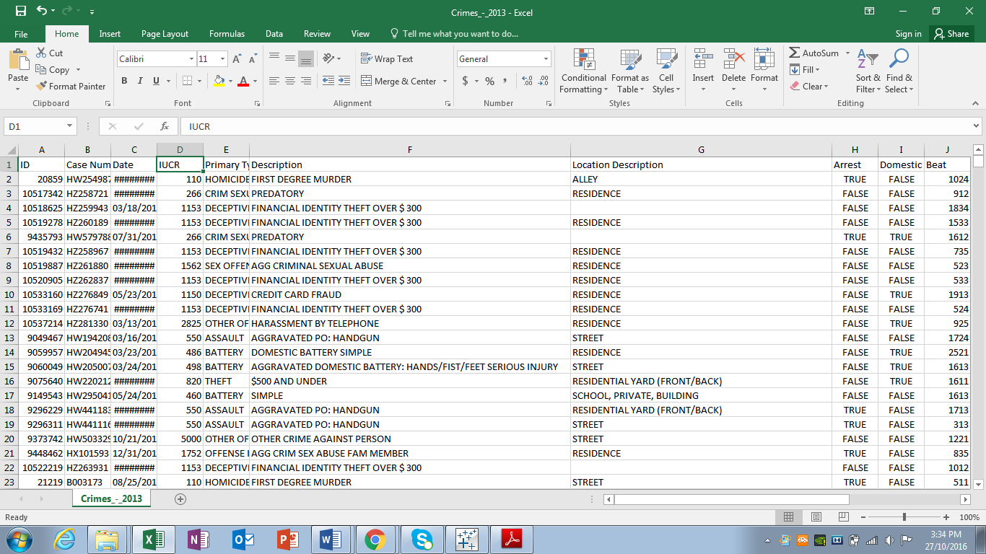

In the same manner some other columns are also eliminated.

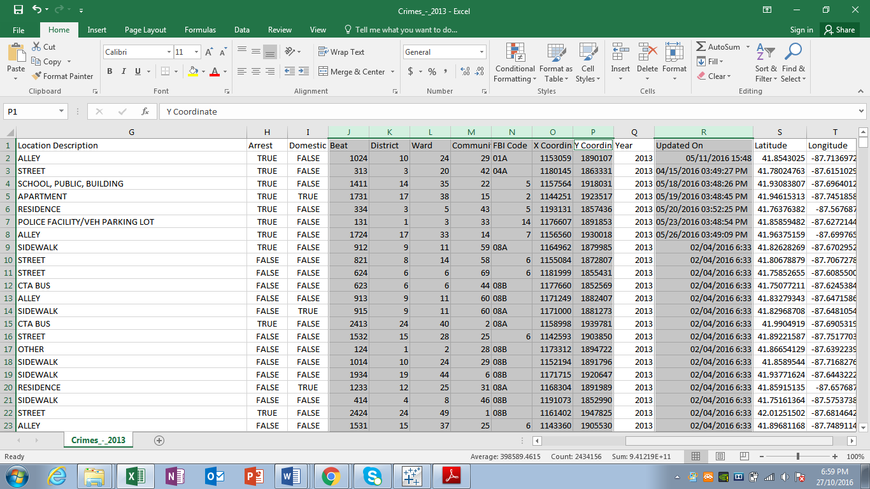

**3. Redundant Columns**

Few different columns had the same values and information hence those columns needed to be cleaned

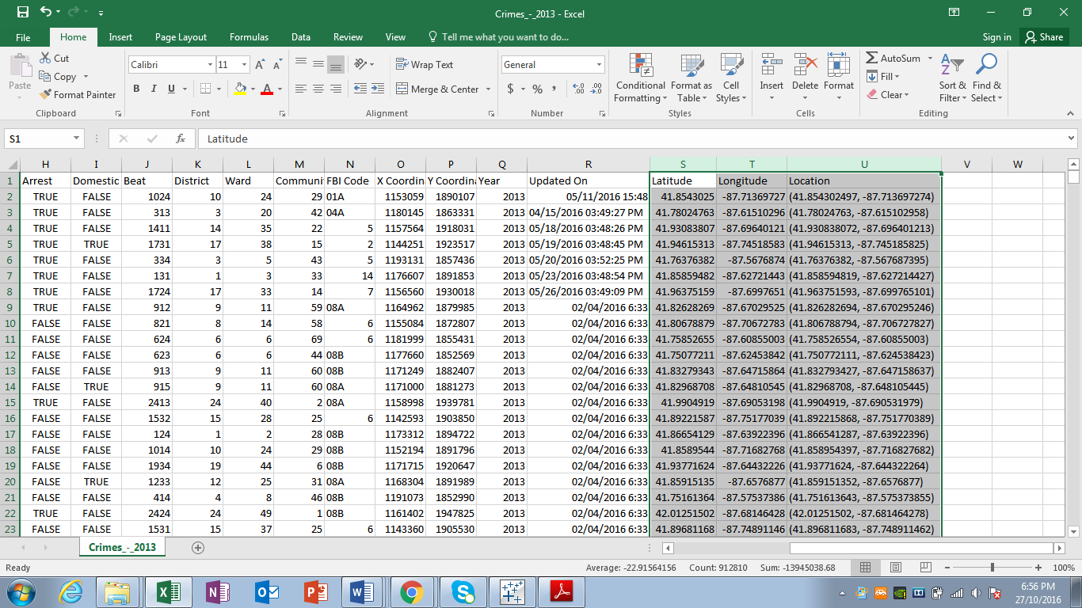

Two other sheets had been cleaned in the same manner and did not required any more cleaning.

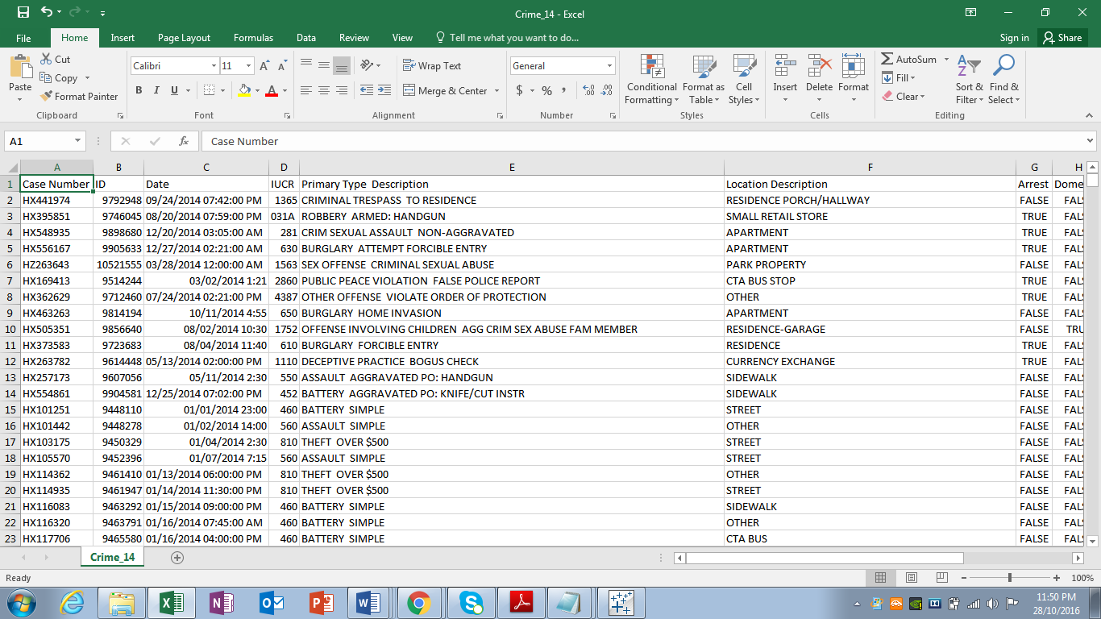

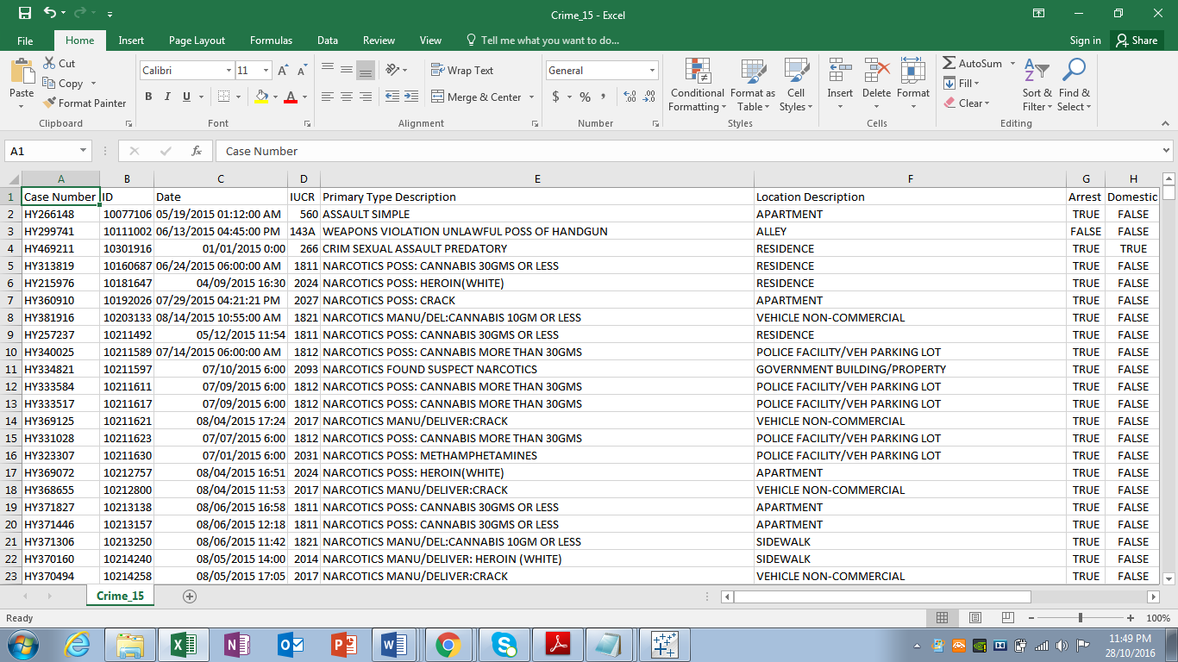

**C. DATA VISUALIZATIONS**

Here are the five questions followed by the screenshots

1. **Which type of crime has been most commonly occurred in different years?**

In the first visualization, we analyzed over Eight Hundred Thousand of rows data against almost as many number of different crimes. In this visualization we have used the **Packed Bubbles** and found out that in last three years of Chicago city’s crime data, the most occurring crime in the city is ‘Theft Under $500 And Under’ with 52,257 reporting’s followed by ‘Simple Domestic Battery’ crime with 51371 reporting’.

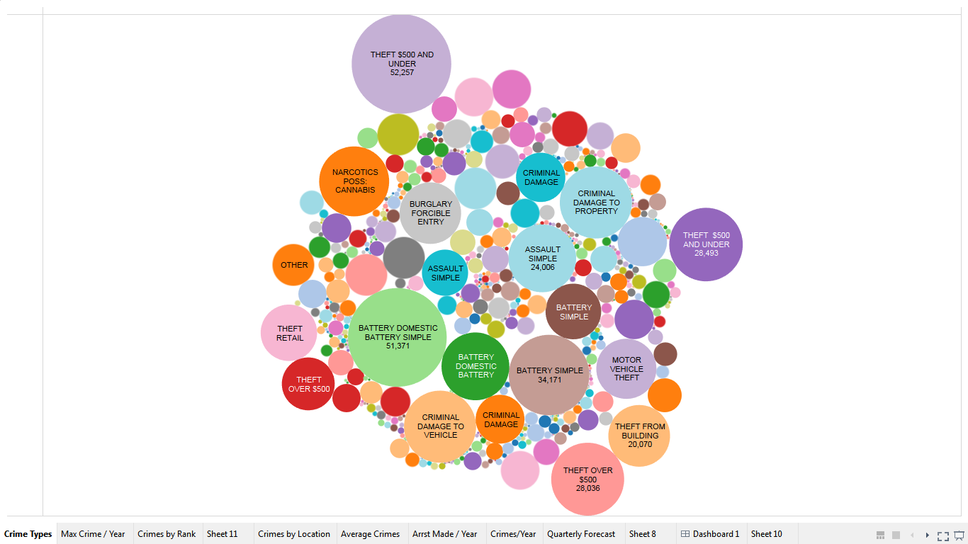

1. **Which Crime in particular had maximum reporting every year?**

Following chart shows which type of crime is had mostly occurred in last three years. The **\*** symbol represents the crime of ‘Theft $500 And Under’ where as the **O** represents the crime of ‘Simple Domestic Battery’. Different color represents the deferent years. From the chart we can easily state that in year 2013 , 2014 , 2015 respectively Chicago city suffered from maximum crime reporting of ‘Theft $500 And Under’ followed by ‘Simple Domestic Battery’.

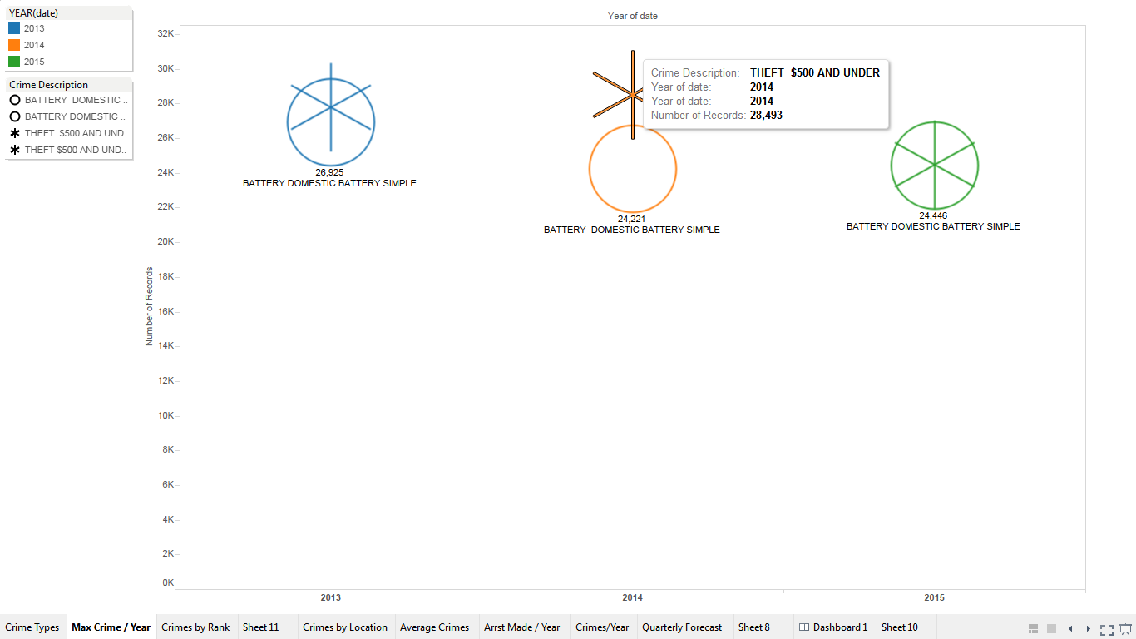

1. **In each year which areas were target the most by the criminals and petty thieves?**

In this particular visualization you can easily see and understand the most targeted areas or locations by the criminals each particular year. The locations that are hit by the crooks are sorted by the **ranks**, most hit location being in the top ranked. The ranks determined for the years 2013, 2014 are compared with year 2015 considering year 2015 as ideal and most recent one.

As you can see from the visualization five different locations have always been the main target for the crooks which are Streets, Residence, Apartments, Sidewalks, Parking lots and garage.

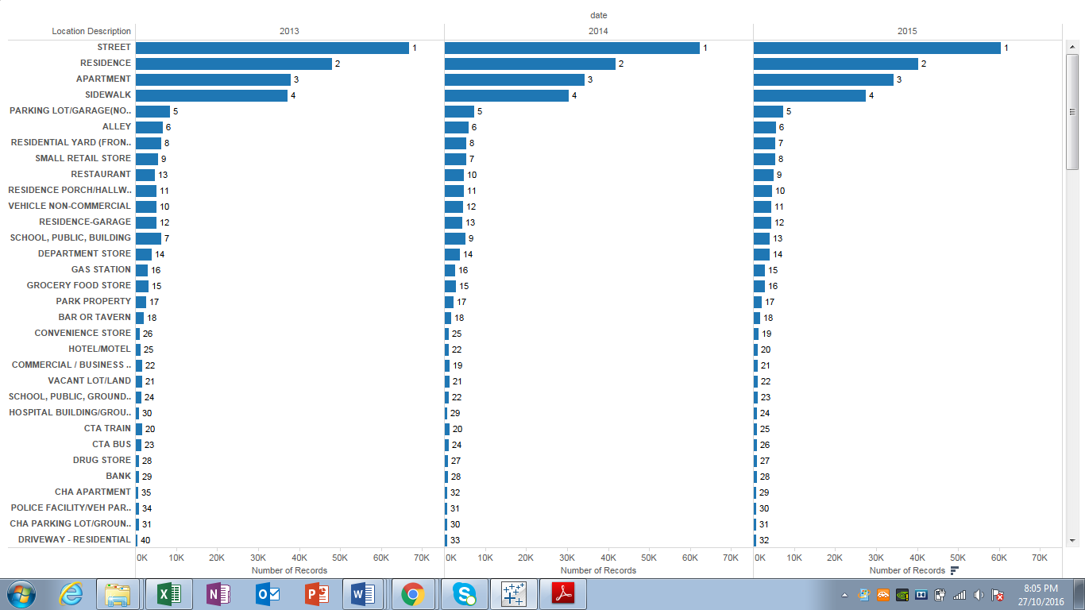

1. **What is the Average number of top crimes reported in the city in given years?**

In this visualization we analyzed the top crimes that are reported each year and found out the Average number of the crime. We have used the **Reference Line** to get the results. As you can see, every years’ Theft is the top crime with the 78,941 reports on average in three years. Whereas, crime of Assault has significantly low average of reporting with 17,180 in given years. This clearly implies that the crime of Theft should be kept watch over as preventive measures should be taken.

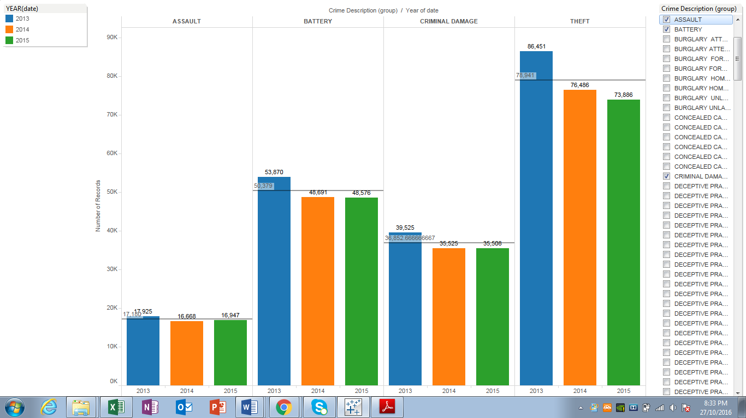

1. **Being the top crime location which crimes have highly took place on the STREET in the most recent year?**

STREETS are the worst location to be hit by the criminals mostly. Number of different crimes have occurred on the streets. The most number of criminal offence reported is ‘Damage to the vehicle’ with 9,847 incidents in year 2015, the recent year. Furthermore, ‘Theft $500 And Under’ and ‘Motor Vehicle Theft’ are the two most common offences with 9,474 and 6,593 number of reporting respectively. There are several other crimes that had occurred on the streets in the recent year 2015.

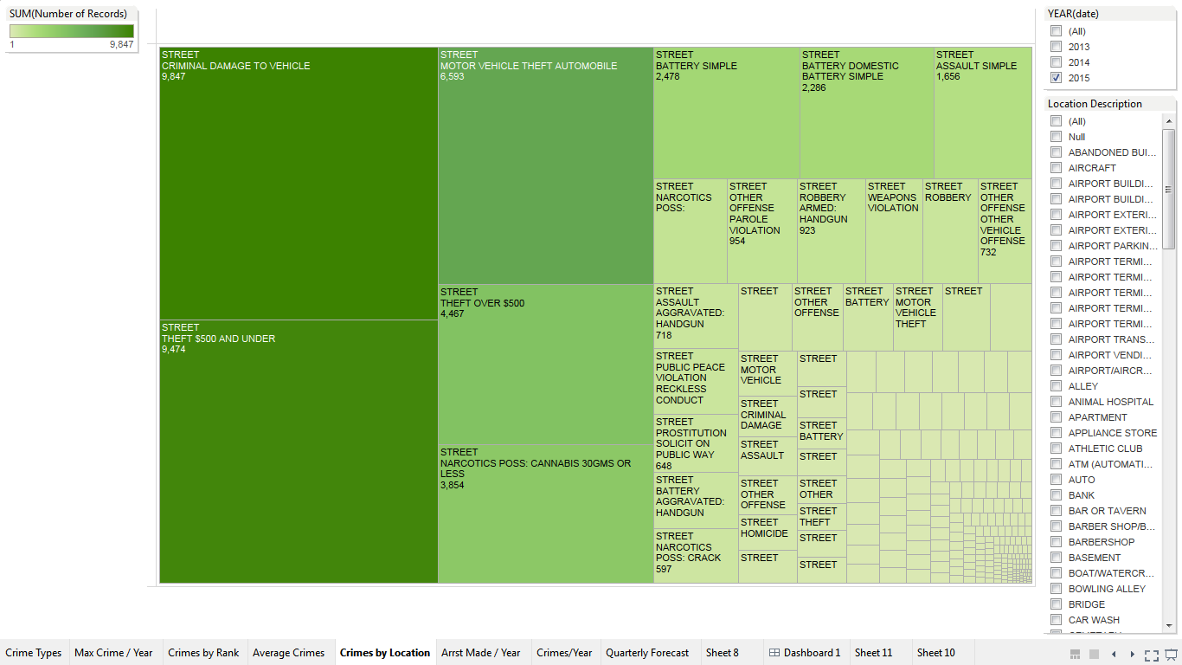

1. **How many Crimes have been reported in each given year and how many crimes had resulted in an Arrest of the criminal?**

In this visualization we can see the number of reported crimes in each year. 304313, 269465, 259824 are the number of crimes reported in the year of 2013, 2014, 2015 respectively. Among these many number of crimes 86037, 78013, 68239 Arrests were made in three consecutive years from year 2013.

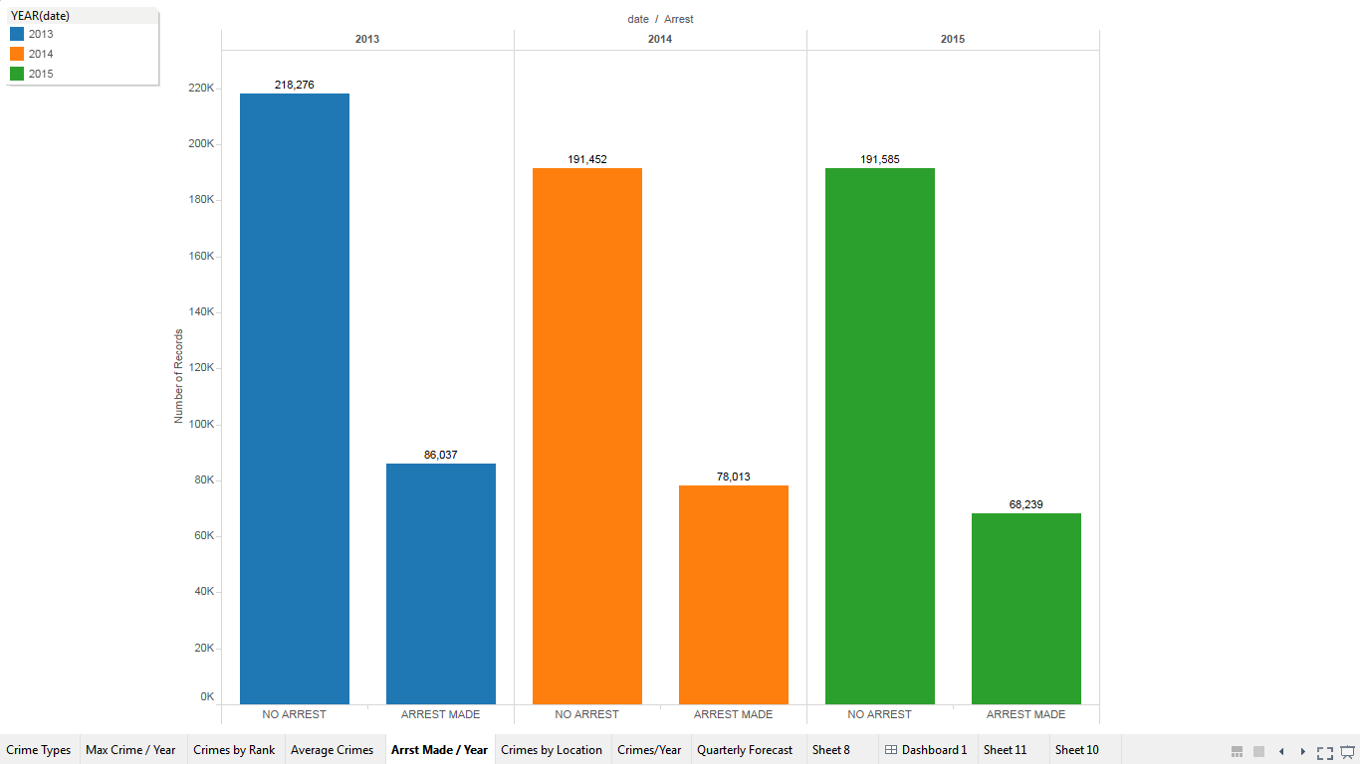

**D. DASHBOARD**

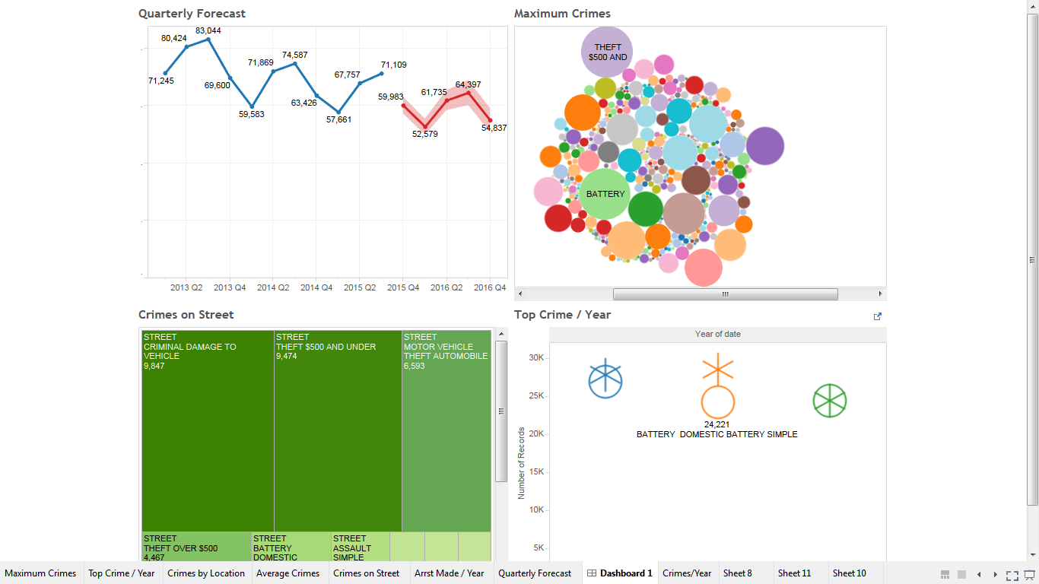

The dashboard has four visualizations, which represents overall summary of the project and what we have done in the project. But, there is only one visualization among the four which is a different one. The very first visualization in the dashboard is a **Forecast** visualization.

It predicts/estimates the number of crimes that might take place in upcoming five Quarters. As you can see from the visualization, it forecasts 52,579 number of crime in the first quarter of 2016 and predicts the hike in next two consecutive quarters of year 2016 with the numbers 61,735 and 64,397 respectively.

**E. STORY TELLING**

May it be past as in ten-twenty years ago or the present as in recent year that has passed, Crime is always has been there. Even if we try to look further beyond our hundred years of history, Crime is still there. Before we had nuclear weapons, we had guns and we had crime. Before we had guns we had knives and crime was still there. No matter how further you go back you couldn’t find crime-free environment. Mankind grew themselves to stop the crimes from happening, we created rules and regulations, guns and bombs to make ourselves feel safe and to stop the crime bus alas! As long as mankind think there is power to possess, crime will be with us as long as we can think of.

Crime does not only include thefts, assaults and narcotics possession. It has wide variety including animal abuse, deceptive practice forgery to battery, burglary and use of arson. Following visualization represents the top crimes that has happened over last few years in city of Chicago.

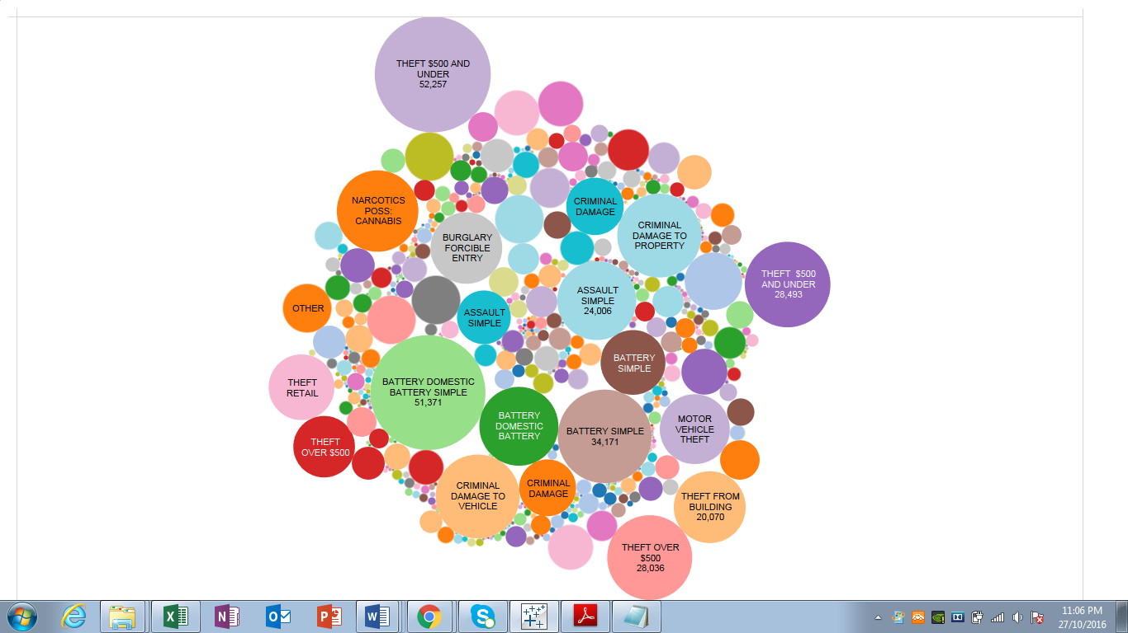

‘Anna Edwards’ from ‘The Daily Mail’ reveals her research about the faces of the criminals existed in 1930’s. Looking at the research we can say that crime has been happening since long time and even in 2015 crime is still thriving. From the visualization it shows that the thefts, narcotics, assaults are the most frequent crimes in Chicago city. According to the study by the ‘Neighborhood Scout’ Chicago is one of the most dangerous city in America. According to the research Chicago is the second most dangerous city. The only thing that is continuously changing about the Crime is Rate. Crime Rate is changing all the time.

Crime rate is the only thing about the crime that is continuously changing. Every year the crime rate goes higher or lower than the previous year. Every time there is a different crime thriving. When one crime goes down other one peeks out. To talk about the city of Chicago in particular, it is getting more and more dangerous to go out. The city has become the dangerous. According to ‘The Wall Street Journals’ the Chicago streets have become the most wildly dangerous place. Numerous different crimes happen on the streets of Chicago. From Homicide, first degree murders to vehicle theft and narcotics. All of the things making the Chicago streets ‘place not to be at.’ ‘Wall Street Journal’ further reports the statements by the Police Offices saying “From patrol to investigation, it’s almost an undoable job now. If I get out of my car, the guys get hostile right away.” As well as a police officer states “People want to fight you; they swear at you. ‘F--- the police, we don’t have to listen,’ they say. I haven’t seen this kind of hatred towards the police in my career”. Following is the visualization of the analysis of the crimes happening on the streets.

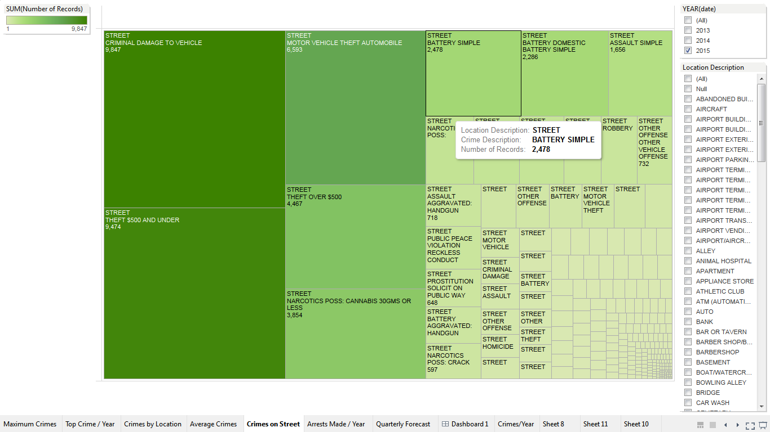

‘The Los Angeles times’ reports that shootings on the streets are becoming frequent thing. Shootings are occurring even on the evenings. The report of the shootings has been constantly being reported. ‘The Los Angeles times’ reports a shooting that occurred about 6 in the evening in the South Chicago Street, when someone opened the fire aiming the bicycle rider, reported by LAPD Officer. Following is the visualization of the analysis of last few years showing the most dangerous location in the Chicago city. It is clear that the Streets are infamous for Crimes.

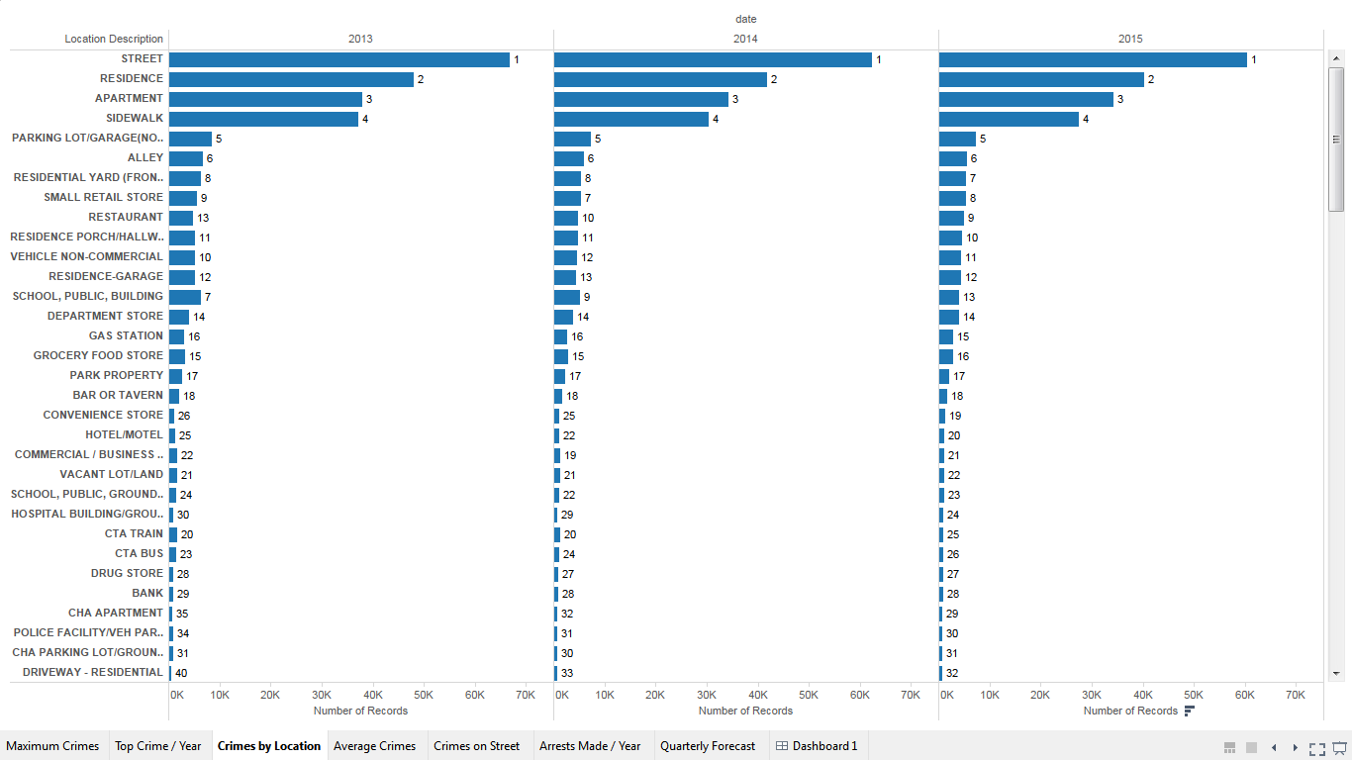

What seems to be the reason for the Streets taking top rank in most dangerous locations in the city? There could be numerous of reasons for that but let’s think about the few reasons.

One of the reasons could be, being an easy target for the criminals. It is easier for the criminals to attack you, run away and vanish in to the crowds. On a crowded street it is easier for the criminal to snatch away your personal belongings and run for it.

The other reason could be poor lighting facilities. At nights poor lighting facilities on the streets makes it difficult for you to see the suspect. Suspects usually takes the advantage of the situation. Poor lighting facilities at nights means more chances of getting robbed or mugged. Well-lit streets could be helpful in reducing crimes.

Furthermore, lack of patrolling in certain streets could also be the reason for streets being the most dangerous place. Lack of Police patrolling on the streets encourages the crimes to happen. Frequent patrolling could help to ease the danger on the streets.

When you think about the safest place to be, you immediately think about your Residence and Apartments. But analysis shows that the Residence and Apartments are the top second and top third places where the crimes have happened the most. According to ‘Chicago Tribune’ which is keeping scrupulous eye on even the daily crimes reported, shows that even in today’s date the Residence and Apartments are the top second and top third most hit places by criminals. What could be the reason for these places to be ranked this high?

One of the reasons could be poor security around the Apartment. Poor security at apartments leaves an opening for the criminals to barge in or to rob the place. Poor security is more often the reason for the forced entry crime.

Unattended home is an open invitation to burglars to make unlawful entry or the crime of home invasion. This could also be the reason behind top ranking of the particular location that is residence and apartments. Making some alternative arrangements while leaving the home could help to stop the criminal offences from happening as well as will help you stay safe.

In addendum, crimes are continuously happening and rising. In a well-developed country like United States rising crimes and crime rate is a problem. Even after known as the superpower, America is facing massive number of crimes every year. And the reason behind it could be small number of Police Officers. Low manpower in the Police Department could be the reason behind crimes cornering the department. It is getting difficult and difficult for the Police Department to keep on everything everywhere. The following visualization explains how Department tremendously low on manpower. You would be able to see the huge difference between arrest made and No arrest made each year by the Police Department.

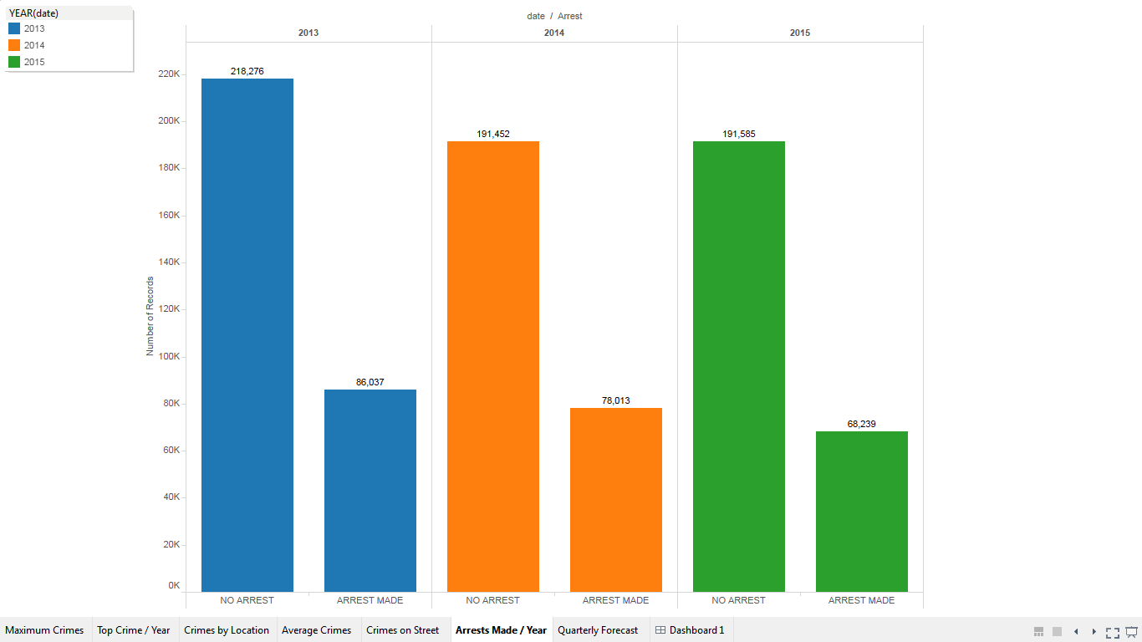

The crimes have been rose dramatically in recent years in Chicago city reports ‘Los Angeles Times’. As the data predicted that the crime rate will increase in upcoming year. The ‘Los Angeles Times’ supports the prediction. According to the Police department, Homicides were up 10%, shooting victims up 12.6%, and aggravated assaults up 27.5%, compared with 2014. Violent crime overall was up nearly 20%. Property crime increased more than 10%. According to the research by ‘Los Angeles Times’ more than 3,000 people already have been shot in the city this year, a number that already has surpassed the 2,980 people shot last year. Similarly, Chicago topped 500 homicides as of early this month after tallying 481 in all of 2015, according to Chicago Tribune data.

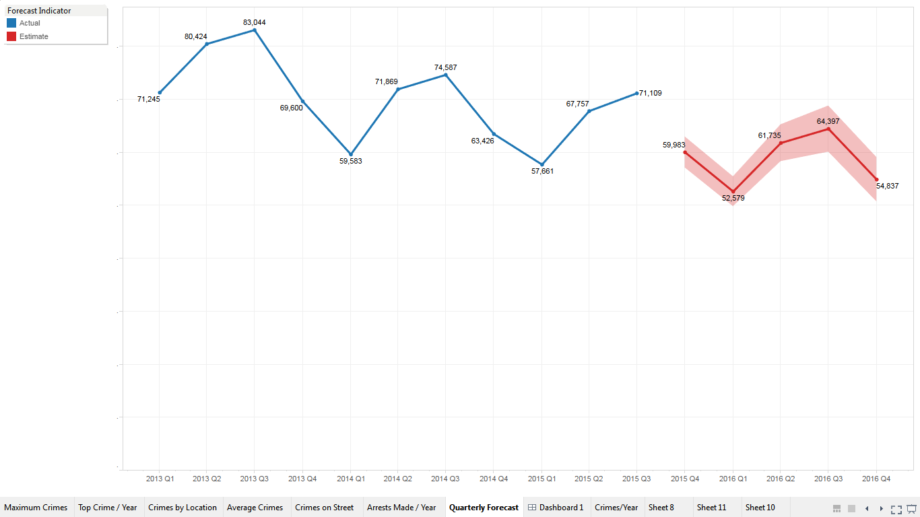

**Conclusion:**

Crimes in the city are under continuous rise. Just analyzing the number of crimes or most dangerous places around the city is not the best way to go while looking for clearing the crime for the city but it is the best possible way to understand the situation of the crimes in the city and act accordingly with whatever sources you have. There could be several reasons contributing to the crimes but Increasing the number of police Officers, Increasing the patrolling during pick timing of crimes, creating awareness in people, educating the people about how, when and where the crime crimes usually takes place, could help contain the crimes from rising. And it will help you feel safe and stay safe.

**REFERENCES**

* ‘Anna Edwards’ (January 2013). 'The Daily mail'

<http://www.dailymail.co.uk/news/article-2255948/Vintage-police-mugshots-reveal-burglars-1930s.html>

* ‘Chicago Tribune’

http://crime.chicagotribune.com/chicago/community/new-city

* ‘The Neighborhood Scout’

<https://www.neighborhoodscout.com/neighborhoods/crime-rates/25-most-dangerous-neighborhoods/>

* ‘The LA Times’

<http://www.latimes.com/local/lanow/la-me-ln-shootings-20160611-snap-story.html>

* ‘The LA Times’

<http://www.latimes.com/opinion/op-ed/la-oe-mac-donald-ferguson-effect-in-los-angeles-20160113-story.html>

* ‘The LA Times’

<http://www.latimes.com/nation/la-na-chicago-police-hiring-20160921-snap-story.html>